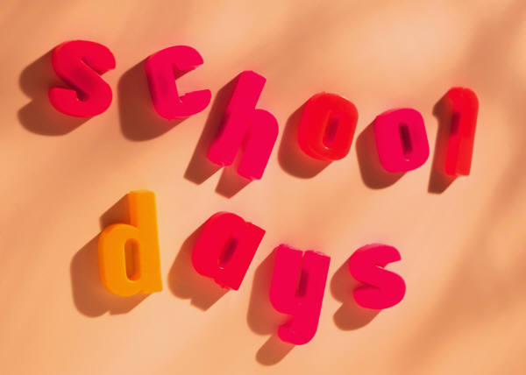
COURSE EXPECTATIONS GR. 5/6

READING – Any work that is not completed by the end of the class period is expected to be turned in the following morning. When we do novels, one day a week will be spent doing reading skill lessons from the workbook. Fifth and sixth grades will be expected to read 60 minutes/week at home.
MATH – Any work that is not completed by the end of the class period is expected to be turned in the following morning. Fifth grade will be expected to make all corrections for full credit. Sixth grade is allowed to make corrections prior to handing their paper in, but once they hand it in that is the grade they will receive. Tests will be given after every five lessons and count for one third of the quarter grade. Fridays will be MOBY Math days which is individualized math instruction on the computer. Lessons are tailored to each individual student. These are not graded.
SPELLING – The spelling work is the responsibility of the student to do during their study hall or at home. Two days a week there will be dedicated classroom time to work on spelling. Tests will be on Friday for fifth grade and on Thursday for sixth grade.
SOCIAL STUDIES – Fifth grade social studies is American History and sixth grade is
World History. A textbook and teacher made units will be utilized to complete the course requirements. All work not completed during class time is expected in the following morning. Projects have their own individual due dates.
SCIENCE - A textbook and teacher made units will be utilized to complete the course requirements. All work not completed during class time is expected in the following morning. Projects have their own individual due dates.
ENGLISH - Fifth and sixth grade classes will be part grammar and part writing. All work not completed during class time is expected in the following morning. Writing projects have their own individual dues dates. The Criterion Writing program will be utilized in addition to other writing projects.

